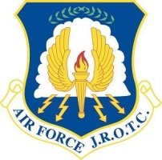 MN-941 Air Force Junior Reserve Officer Training Corps 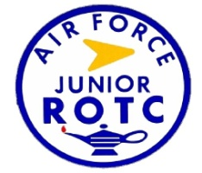

Welcome New Cadets

Welcome to the Minnesota 941st Air Force Junior Reserve Officer Training Corps (AFJROTC)! You are now a valued member of our Cadet Corps. We are dedicated to making your AFJROTC experience interesting and educational, with a lot of fun thrown in along the way!

Our mission is to “develop citizens of character dedicated to serving their nation and community.” The AFJROTC program is grounded in the Air Force core values of Integrity First, Service Before Self, and Excellence in All We Do. We need you to put forth your best effort every day to ensure success of our program. AFJROTC is all about participation—and everybody can find ways to participate because we offer many activities.

The AFJROTC curriculum consists of aerospace-related academic instruction enhanced by leadership and wellness education. It also hosts many extra-curricular activities including a Color Guard Team, Sports Team, Drill Team, Knowledge Bowl Team, and Orienteering Team, among many others. There are also community service opportunities as well as a variety of events such as an icebreaker and quarterly group events, various sports competitions, a military ball, and promotion and awards ceremonies, to name a few. These are great opportunities to build teamwork skills and all cadets are encouraged to participate in as many activities as they can. The Senior Aerospace Science Instructor (SASI) and Aerospace Science Instructor (ASI) oversee and direct the program while the cadet corps senior leaders lead and manage it. This program allows cadets to grow as leaders and it provides them an avenue to experience the management of an established organization.

Please be aware, as a member of AFJROTC, you are REQUIRED to wear the AFJROTC blue service uniform and fatigue camouflage pattern uniform on alternating weeks throughout the year. Males are required to be clean-shaven and maintain a military-style haircut and females must wear their hair “put up” while in uniform, in addition to other grooming standards. You will also be issued a physical fitness uniform T-shirt and shorts, as well as a unit polo shirt. There is an initial activity fee of $25, but that is the only required payment for you for the entire academic year.

Congratulations on your decision to enroll in the AFJROTC program, you have taken the first step. We look forward to this school year and to meeting you and helping you on your fun journey in AFJROTC.

Welcome Cadet!

Colonel Dwight K. Dorau, Senior Aerospace Science Instructor

Master Sergeant Wendy K. Goetz, Aerospace Science Instructor

